**BIG DATA LAB-03**

Adding extra values

>db.employee.insertMany([{Id:104,Name:"sushmitha",Age:30,sex:"F",PhoneNo:"7834627899",Place:"mysore"},{Id:107,Name:"suchitra",Age:32,sex:"F",PhoneNo:8925237827,Place:"mangalore"},{Id:109,Name:"John",Age:35,sex:"M",PhoneNo:9374623757,Place:"udupi"}])  
{  
"acknowledged" : true,  
"insertedIds" : [  
ObjectId("62677213ea1f4611efa54f67"),  
ObjectId("62677213ea1f4611efa54f68"),  
ObjectId("62677213ea1f4611efa54f69")  
]

}

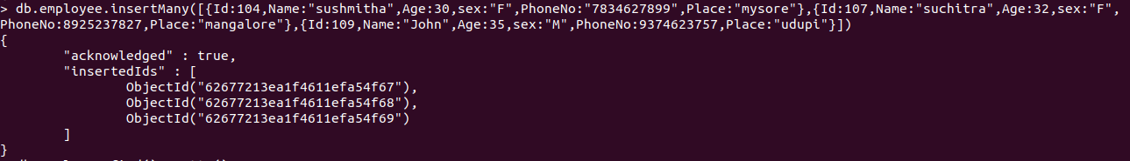

Output:

> db.employee.find().pretty()  
{  
"_id" : ObjectId("624bbc3ca0d049924c5006c9"),  
"Id" : 101,  
"Name" : "soni.a",  
"Age" : 28,  
"sex" : "F",  
"PhoneNo" : 9837791737,  
"Place" : "Bangalore"  
}  
{  
"_id" : ObjectId("624bbe0ba0d049924c5006ca"),  
"Id" : 101,  
"Name" : "Sonal.M",  
"Age" : 27,  
"sex" : "F",  
"PhoneNo" : 7637791737,  
"Place" : "Bangalore"  
}  
{  
"_id" : ObjectId("624bbe0ba0d049924c5006cb"),  
"Id" : 102,  
"Name" : "Prathap.K",  
"sex" : "M",  
"Phone" : 9874255456,  
"Place" : "Bangalore"  
}  
{  
"_id" : ObjectId("624bbe0ba0d049924c5006cc"),  
"Id" : 103,  
"Name" : "Sampreeth",  
"Age" : 27,  
"sex" : "M",  
"PhoneNo" : 6783327876,  
"Place" : "Bangalore"  
}  
{  
"_id" : ObjectId("62677213ea1f4611efa54f67"),  
"Id" : 104,  
"Name" : "sushmitha",  
"Age" : 30,  
"sex" : "F",  
"PhoneNo" : "7834627899",  
"Place" : "mysore"  
}  
{  
"_id" : ObjectId("62677213ea1f4611efa54f68"),  
"Id" : 107,  
"Name" : "suchitra",  
"Age" : 32,  
"sex" : "F",  
"PhoneNo" : 8925237827,  
"Place" : "mangalore"  
}  
{  
"_id" : ObjectId("62677213ea1f4611efa54f69"),  
"Id" : 109,  
"Name" : "John",  
"Age" : 35,  
"sex" : "M",  
"PhoneNo" : 9374623757,  
"Place" : "udupi"  
}

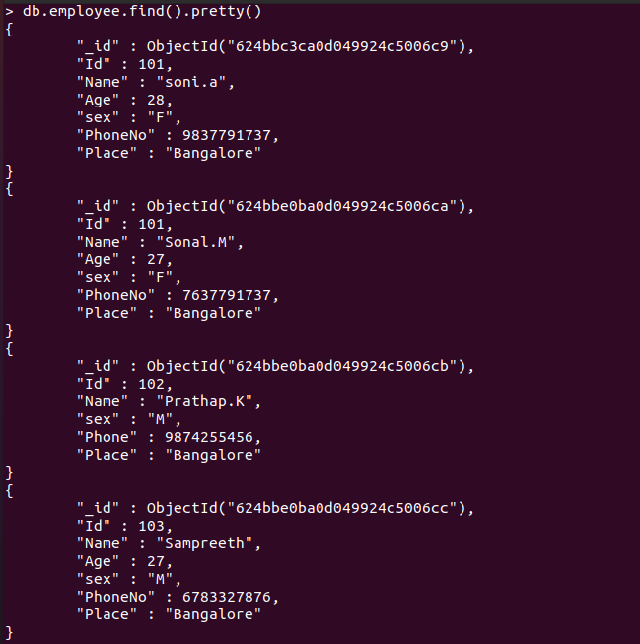

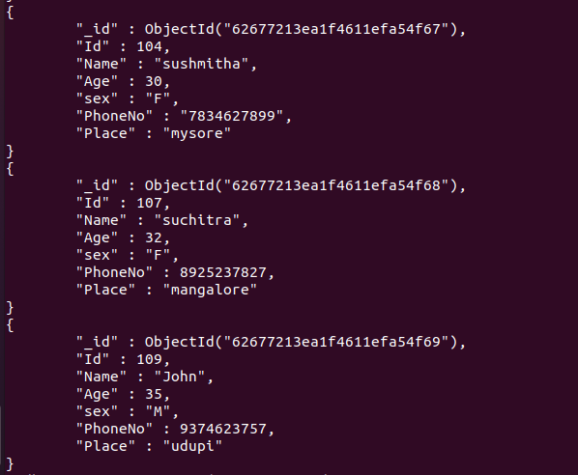

**AGGRETATE FUNCTION:**

1. **SUM**

> db.employee.aggregate([{$group:{_id :"$sex",same_Age: {$sum :"$Age"}}}])

**OUTPUT:**  
{ "_id" : "F", "same_Age" : 117 }  
{ "_id" : "M", "same_Age" : 62 }



1. **AVERAGE**

> db.employee.aggregate([{$group:{_id :"$sex",same_Age: {$avg :"$Age"}}}])

**OUTPUT**{ "_id" : "F", "same_Age" : 29.25 }  
{ "_id" : "M", "same_Age" : 31 }



1. **FIRST**

> db.employee.aggregate([{$group:{_id :"$Name",same_Age: {$first :"$Id"}}}])

**OUTPUT:**  
{ "_id" : "suchitra", "same_Age" : 107 }  
{ "_id" : "Sampreeth", "same_Age" : 103 }  
{ "_id" : "Prathap.K", "same_Age" : 102 }  
{ "_id" : "Sonal.M", "same_Age" : 101 }  
{ "_id" : "soni.a", "same_Age" : 101 }  
{ "_id" : "sushmitha", "same_Age" : 104 }  
{ "_id" : "John", "same_Age" : 109 }

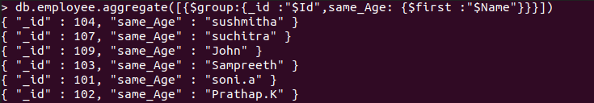

4**)PUSH**

> db.employee.aggregate([{$group:{_id :"$Name",same_Age: {$push :"$Id"}}}])

OUTPUT  
{ "_id" : "Sampreeth", "same_Age" : [ 103 ] }  
{ "_id" : "sushmitha", "same_Age" : [ 104 ] }  
{ "_id" : "Sonal.M", "same_Age" : [ 101 ] }  
{ "_id" : "Prathap.K", "same_Age" : [ 102 ] }  
{ "_id" : "John", "same_Age" : [ 109 ] }  
{ "_id" : "soni.a", "same_Age" : [ 101 ] }  
{ "_id" : "suchitra", "same_Age" : [ 107 ] }

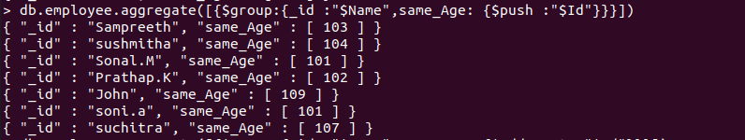

**5)ADDTOSET**

> db.employee.aggregate([{$group:{_id :"$Name",same_Age: {$addToSet :"$Id"}}}])

**OUTPUT:**  
{ "_id" : "suchitra", "same_Age" : [ 107 ] }  
{ "_id" : "Sampreeth", "same_Age" : [ 103 ] }  
{ "_id" : "Prathap.K", "same_Age" : [ 102 ] }  
{ "_id" : "Sonal.M", "same_Age" : [ 101 ] }  
{ "_id" : "soni.a", "same_Age" : [ 101 ] }  
{ "_id" : "sushmitha", "same_Age" : [ 104 ] }  
{ "_id" : "John", "same_Age" : [ 109 ] }

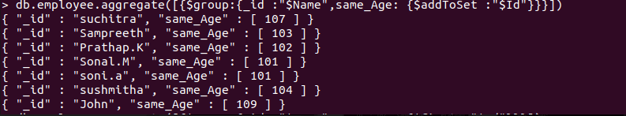

**6)MINIMUM**

> db.employee.aggregate([{$group:{_id :"$sex",same_Age: {$min :"$Age"}}}])

**OUTPUT:**  
{ "_id" : "F", "same_Age" : 27 }  
{ "_id" : "M", "same_Age" : 27 }



**7)MAXIMUM**

> db.employee.aggregate([{$group:{_id :"$sex",same_Age: {$max :"$Age"}}}])

**OUTPUT:**  
{ "_id" : "F", "same_Age" : 32 }  
{ "_id" : "M", "same_Age" : 35 }



**8)LAST**

> db.employee.aggregate([{$group:{_id :"$Name",same_Age: {$last :"$Id"}}}])

**OUTPUT:**  
{ "_id" : "suchitra", "same_Age" : 107 }  
{ "_id" : "Sampreeth", "same_Age" : 103 }  
{ "_id" : "Prathap.K", "same_Age" : 102 }  
{ "_id" : "Sonal.M", "same_Age" : 101 }  
{ "_id" : "sushmitha", "same_Age" : 104 }  
{ "_id" : "John", "same_Age" : 109 }

